AI in Action: How Businesses Are Quietly Redesigning Workflows
A snapshot of commercial AI shaping decisions today
AI is no longer something companies are “experimenting” with on the side. Over the past month, several commercial AI releases have moved directly into core business workflows, changing how products are designed, how operations are run, and how revenue is generated. The real shift isn’t flashier demos, but AI becoming part of how real work gets done.
This newsletter highlights three industries where AI is already delivering tangible business value and influencing day-to-day decision-making.

Industries Covered
- Manufacturing and Quality Systems
- Automotive and Mobility
- Enterprise Operations and Cloud Services

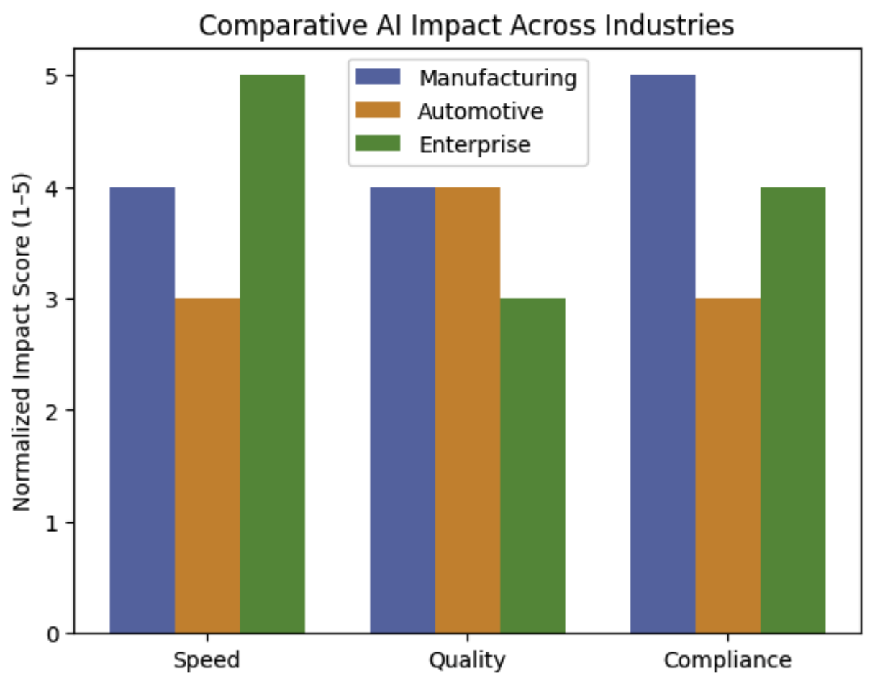

Manufacturing: AI Inside Quality and Change Management
What’s new
Manufacturing software providers have introduced AI capabilities inside Product Lifecycle Management (PLM) and Quality Management Systems (QMS) to automate document reviews, engineering change analysis, and compliance checks.
How it’s being used
Instead of engineers spending hours manually comparing specifications, supplier documents, and revisions, AI tools now flag differences, highlight potential risks, and help speed up approval workflows.
Why is that important?
- Engineering change orders move faster
- Compliance risk is reduced
- Rework and audit costs are lowered
Outlook
As these systems continue to improve, AI is likely to identify quality risks earlier in the lifecycle, helping manufacturers prevent issues instead of reacting to them after production has already started.

Automotive: AI Becomes a Revenue Line Item
What’s new
Automakers are increasingly offering AI-powered driver assistance and autonomy features as paid upgrades, supported by their own hardware and software platforms.
How it’s being used
Features such as lane assistance, adaptive driving, and real-time environment analysis are now sold as premium options rather than included by default.
Why it matters
- Automakers unlock new recurring revenue
- Software becomes a key differentiator
- Less reliance on third-party AI vendors
What the future holds.
Vehicles are steadily becoming software-defined products, where AI updates extend functionality and value long after the initial purchase.

Enterprise Operations: AI Agents Join the Workflow
What’s new
Cloud providers have released AI agent platforms that connect directly to internal systems like finance, HR, and IT support.
How it’s being used
Companies deploy these agents to triage tickets, generate reports, and handle repetitive decision tasks that would otherwise require human intervention.
Why it matters
- Operational efficiency improves
- Decisions happen faster
- Support teams spend less time on routine work
What we can look forward to
As governance and monitoring improve, AI agents are likely to become trusted parts of enterprise operations rather than experimental tools running in isolation.

The Bigger Picture
Across all three industries, the pattern is the same: AI is moving from optional innovation to embedded infrastructure. The companies seeing real returns are not the ones chasing every new model, but the ones integrating AI directly into critical processes with clear ownership and measurable outcomes.
The next competitive advantage will come from how well organizations align AI with business strategy not from adopting AI simply because it exists.

References
PR Newswire. (2025, November). PTC introduces Arena AI Engine to enhance PLM and QMS workflows.
https://www.prnewswire.com/
Reuters. (2025, November). Rivian unveils in-house autonomy processor and paid driver assistance features.
https://www.reuters.com/
The Verge. (2025, November). Rivian’s autonomy strategy signals shift toward software-defined vehicles.
https://www.theverge.com/
Amazon Web Services. (2025, December). AWS announces Bedrock AgentCore and expanded AI infrastructure at re:Invent 2025.
https://www.aboutamazon.com/

